Mark My Vords

CS 172-1

Project Specifications

The design of our project is to help educators with grading multiple choice tests using a console application. The problem we are trying to solve is to write a program that enables instructors to easily use the code and input the correct answers for the program to write. In addition, the application contains constructors that allows teachers to designate one correct answer. This allows teachers to save time on grading and computing averages of all tests in a course as well as the student average score for each individual test. It provides the contingency for educators to track students’ progress, and class improvements.

The requirements for this project are implemented in simply two different classes using templates and vectors. Our program runs on two primary classes: *Test* and *Students*. *Test* is charged with knowing all data pertinent to the individual test, as well as how to implement the answer key in such a way that all students’ tests will be rectified. The *Students* class will have one counter incremented according to the number of correct answers a student inputs, an ID identifier per student, as well as the ability to calculate a percentage of total test scores. The *Test* class is designed with getters and setters corresponding to number of questions, position of said questions, and the resulting correct answer option. In addition to these functions, the *Test* class records what test is being considered, the number and position of various questions, and a set of three char values elucidating the correct option in accordance with the key.

The operators contained in *Students* facilitate three main operations: getters for relative information regarding ID number, NumAnsCorrect() displays individual answers correct, NumberAnswersCorrect() corresponds to total correct for all respective tests, and pointer \*getAns retrieves input for grading. *Students* maintains operators for setting aforementioned ID number and NumberAnswersCorrect (for a variable number of tests). The pointer \*Ans(int num) corresponds to the possible number of options assigned for each test question, we utilized this so that we might, for example, limit true/false questions to two options. The operand compareAns(char \*pointer, char \*correctAnswerPointer, int num) compares the pointer to student’s inputted answer, the pointer to correct answer found in the key, and returns an int corresponding to correct or incorrect.

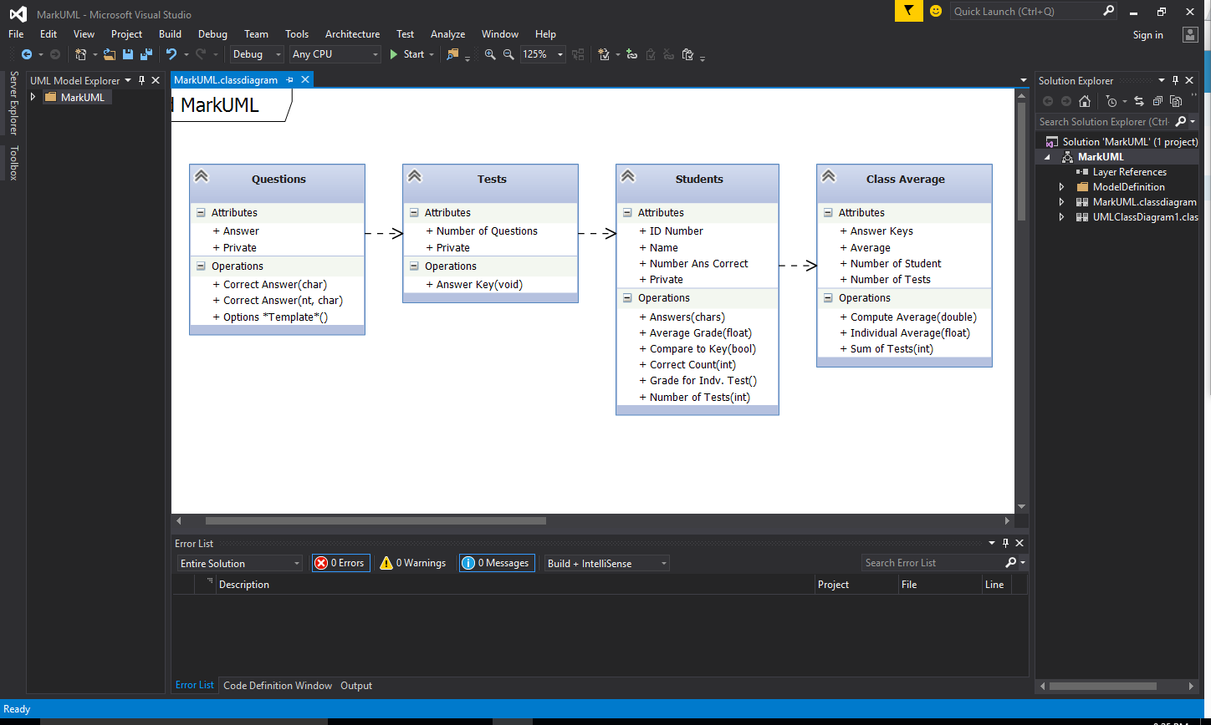Original:

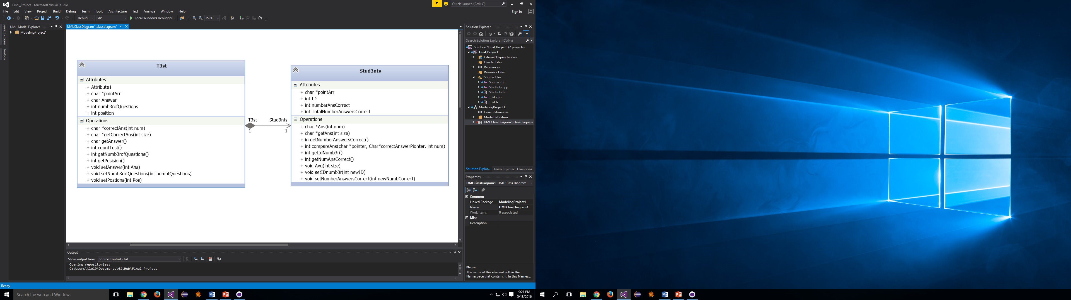Revised: